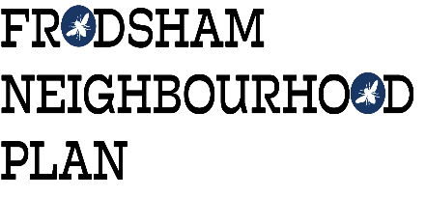
CALL FOR SITES

BACKGROUND

Frodsham Neighbourhood Plan (FNP) is a way to help communities influence the planning and future land use of the area in which we live and work. Its purpose is to help ensure that development is suitable, sustainable and meets the needs of the community by identifying the facilities, services and infrastructure needed.
More information is available at: www.frodshamplan.org.uk
FNP Steering Group is now at the stage of collecting information on potential sites for development which will meet the future needs of Frodsham. This process is called a ‘Call for Sites’.

WHAT IS A CALL FOR SITES?
A ‘Call for Sites’ is an informal way for land owners, land agents, individuals and organisations to propose sites in Frodsham.
The proposed land use could be for commercial, community facilities, employment, housing (including self-build and affordable housing), leisure, play or activity areas, retail or tourism etc.
Putting a site forward does not commit you or the FNP in any way, but enables the FNP Steering Group to consult with the community about possible future development in Frodsham

WHY ARE WE ‘CALLING FOR SITES’?

Frodsham is heavily constrained for development due to the surrounding Green Belt, Flood Plains, Conservation Areas and Sites of Special Scientific Interest. It is important that the future needs of the community are met through appropriate planning. This ‘Call for Sites’ covers the whole of the Frodsham Neighbourhood Plan area.

Please refer to the link below for a map of the FNP area:
http://consult.cheshirewestandchester.gov.uk/events/16748/popimage_d1534334e2320.html
Once the suggested sites are received, they will be assessed by an Independent Planning Specialist against three criteria:
- is the site suitable
- is the land available
- is the proposed option achievable
The site suggestions and independent assessments received by the FNP will be used to inform the preparation of the policies.
The community’s views about the suggested sites will be sought and considered before a final draft Plan is submitted for external examination via Cheshire West and Chester. There will be a referendum in the local community before the FNP is implemented.
Suggesting a development site does not mean it will be automatically included in the Plan, or that planning permission will be granted. Planning permission will have to be sought through the statutory process with CWaC.

HOW CAN A SITE BE SUGGESTED?
If you wish to suggest a site, please complete the Application Form and email it to:
frodshamplan@gmail.com
or via the FNP website: www.frodshamplan.org.uk/documents/call-for-sites and pressing the SUBMIT button at the bottom of the form
or by post to:
Frodsham Neighbourhood Plan,
Castle Park House,
Frodsham
WA6 6SB
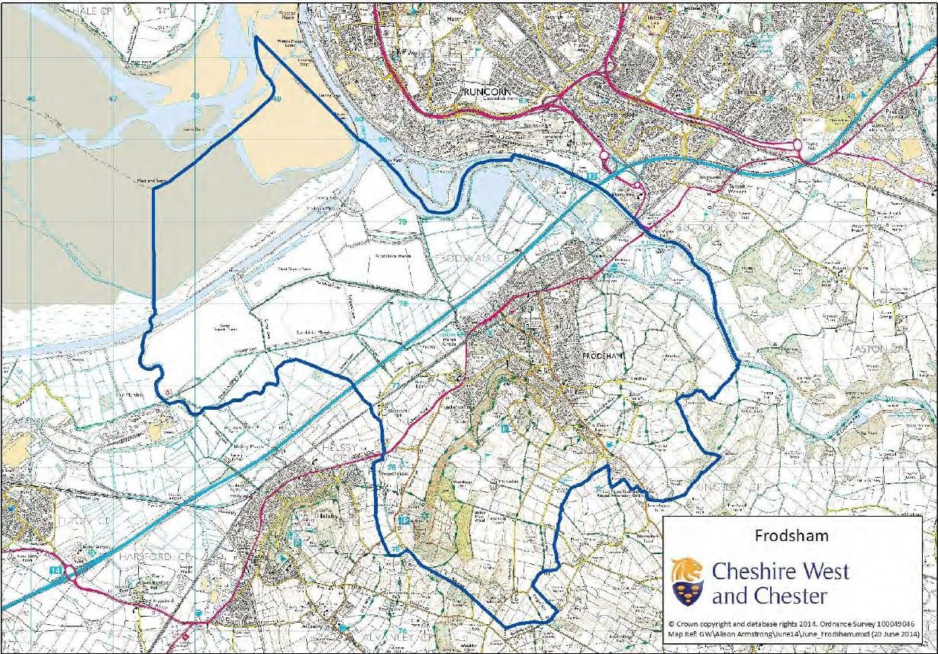
The deadline for ALL applications is: 18.00 on Friday 4th May 2018
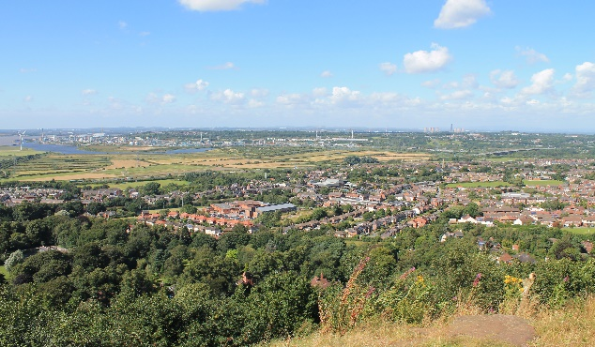
Please feel free to pass this information to anyone else who may be interested.

